PROJECT REPORT ON  
  
PUBLIC TRANSPORTATION EFFICIENCY ANALYSIS  
  
SUBMITTED BY  
  
B.LAVANYA  
  
PERI INSTITUTE OF TECHNOLOGY  
  
MANNIVKKAM

VISHUALIZING ON TIME PERFORMANCE

USING PYTHON CODE

We are going to use a few Python libraries:

* Pandas as pd → read data and store in a dataframe
* MatPlotlib as plt → graph data
* Networkx as nx → graph data as nodes if they communicated

Next, load your data based on its file path. Looking at our data frame, we see the columns →‘No.’, ‘Time’, ‘Source’, ‘Destination’, ‘Protocol’, ‘Length’, ‘Info’

Looking at our data row by row doesn’t reveal much information.

Now that our data is in a neat data frame, we can use the functions:

* groupby() → select column to identify and ***group by*** unique values
* count() → count how many times a value appears in the data frame as a value
* sort_values → display values based on size

We are going to use these functions to understand devices that ***initiated*** conversations, ***accepted*** communications, and ***types*** of communications.

Taking a look at “sources” reveals which devices had the least/most number of communications.

This type of information is worth noting if you are analyzing network traffic because some IPs might be from unknown devices (which can mean they are malicious) or are showing an abnormal amount of activity.

If you investigate “protocols”, you’ll see a few HTTP types of communications.

CODE

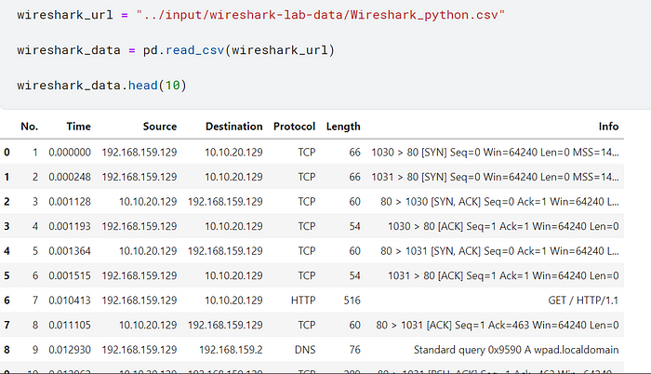

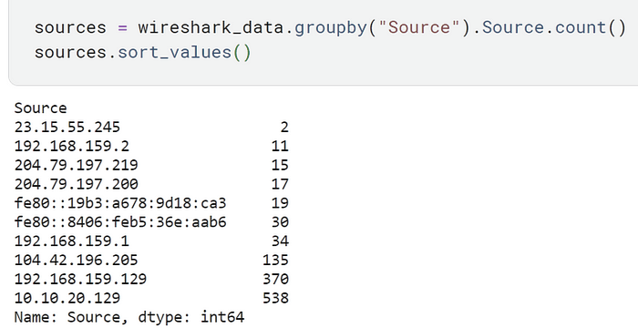

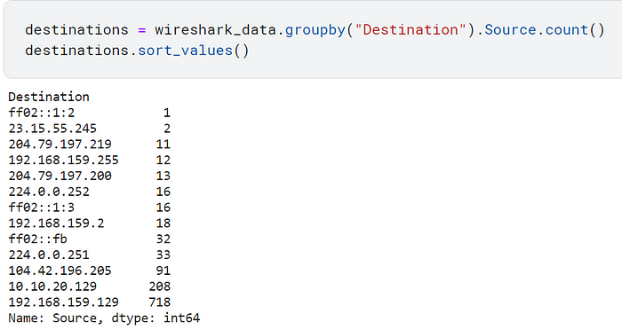

PUBLIC FEEDBACK

Related work

Currently, the disruption management cares mainly about timetable adjustment, rolling stock and crew rescheduling (Jespersen-Groth et al., 2009). Customer information sometimes is indirectly integrated by staff reports and is then displayed towards the dispatcher (Informationssystem Transportleitung Personenverkehr). The notification of customers in a timely and consistent manner, is currently not a highly prioritized aspect in disruption recovery.

Necessity for automated customer feedback

In this section the needs for automated customer feedback is derived from the transportation companies’ point of view and from the travellers’ point of view as both actors are relevant for the improvement of service quality

Implementing automated customer feedback

In this section we present a way to transfer data between travellers and transportation companies. For this, we define constraints in Section 4.1, then we present a novel architecture including interfaces in Section 4.2 and an example implementation.

Using automated customer feedback

A typical journey with public transport provides several opportunities for customers to provide information. At the moment, social networks allow for an unstructured way of collecting this information, mainly serving as a replacement for other communication technology, e.g. service points and call centres. Especially mobile applications can provide a more structured way for collection feedback information. The Munich linked transport system (MVV) for example uses the mobile application MVV

Discussion

The idea of interacting electronically with the customer is not new. However, existing approaches are mainly focused on social media, e.g. (Austin, 2011, Deutsche Bahn Facebook page, 2014, Bregman, 2012). While these approaches provide a base for further developments, they are mainly serving as another communication channel. Partially, information relevant for the operation is posted through social media channels. But the information is generally unstructured and cannot be automatically…….